**Dr.D.Francis Xavier ChristopherM.Sc, Ph.D**

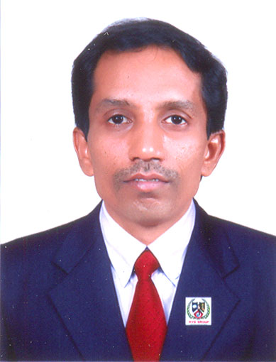

**Address( Office) (Residence)**

Associate.Prof. & Director Cynthia Villa, 6 /231 , Jothi Nagar,2nd St.

School of Computer Studies Podanur

Rathnavel Subramaniam College of Arts & Science Coimbatore – 641 023

Sulur, Coimbatore - 641 402

Email: christopherd@rvsgroup.com

Mobile : 8838471551

_____________________________________________________________

**EXPERIENCE**

Total Teaching experience (UG& PG) : 20 Yrs ( UG – 20 yrs, PG – 19 yrs)

Total experience including Industrial Experience: 20 Yrs

Experience after Ph.D : 4 yrs 6 Months

# EDUCATIONAL QUALIFICATIONS :

Ph.D. : Qualified in March 2014 from Bharathiar University

Title of the thesis : DETERMINING SOFTWARE REQUIREMENTS STABILITY \

BASED ON COMPLEXITY POINT MEASUREMENT

ADOPTING MULTI-CRITERIA FUZZY APPROACH

AUGMENTING QUALITY MODELS

M.Phil. : Qualified in May 2001 from Bharathiar University

Title of the thesis : Effectiveness of Networking Protocols in WAP Gateway

PG : Qualified in May 1998 from Bharathiar University

Research Interest : Software Engineering – Agile, Networking – Cloud

Computing

## ACADEMIC ACHIEVEMENTS

Research Papers published : 36

Research Papers Presented : 15

Book Published : Nil

Seminars / Conferences organized : 15

**COUNTRIES VISITED FOR PRESENTING RESEARCH PAPERS**: China, U.K

**RESEARCH GUIDANCE (PhD&M.Phil)**

**Ph.D : Awarded: Nil Ongoing : 8 Awaiting Viva : Nil**

**M.Phil : Awarded : 72 Ongoing : 1**

**OTHER EXPERIENCES - NIL**

